# DESIGN ANALYSIS - **CRITERIA TABLE**

Note: we provide an example based on a flyer for a school event just to guide you how to complete this table.

To submit:

1. Individual work. Select 2 or 3 pages on a magazine to analyze.
   * You can select a paper magazine or a web magazine
2. **Insert screenshots of your magazine pages** you have selected regarding this design analysis work.
3. Replace the **last column with your design analysis**.
   * You can write in Khmer or English

MAGAZINE

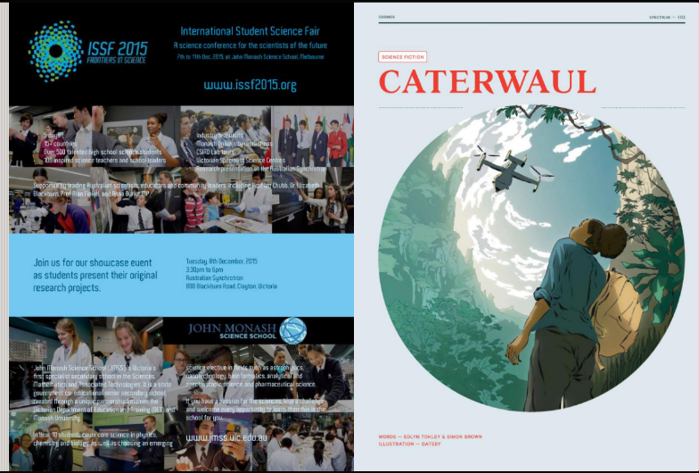

|  |  |  |
| --- | --- | --- |
| CATEGORY | CRITERIA | EXAMPLE OF ANALYSIS |
| **FONT** | The **fonts**, the **font size**, and style are well selected and create a visual **interest** | *Fonts is good. Font size also is good, because the tittle ISSF is big and text frontiers in science under tittle is smaller than ISSF, fonts style are well. But It have three fonts style.*  *We should use a little font that we can use.* |
| **COLOR** | The **color palette** is well selected and create a visual **interest** | *The design uses four color. So I think good. Because one white color complete with text on the picture, color all text is the same. And the last text color is related to logo ans also tittle.*  *The color is well selected and create a visual interest.* |
| **COMPOSITION** | The layout of the design well-organized and **easy to follow**, with a clear **hierarchy** of information | *The layout of the design is well-organized and easy to follow, with a clear hierarchy of information. The use of white space and alignment helps to create a clean and professional look.* |
| **CONTRAST** | Is there sufficient **contrast** between the different elements of the design to **make them stand out** and create visual interest | *The use of contrast in the design could be improved, we should improved color text on the picture. Because those text is white so it make us to watch not easy.*  *The event image stands out but the body text is difficult to read* |
| **BALANCE** | Is the design **balanced** in terms of its use of space, text, and graphics | *The design is well-balanced in terms of its use of space, text, and graphics.*  *The event information is clearly presented and does not feel cluttered.* |
| **PROXIMITY** | Are related elements of the design **grouped** together to create **visual unity** and **hierarchy** | *The related elements of the design are grouped together effectively, with the event title, date, and location presented in a clear and organized manner.* |
| **REPETITION** | Is there consistent use of design elements (such as fonts, colors, and graphics) throughout the design to **create visual unity** | *The design repeated between text and color background. For graphics is good. Because we can read and easy to watch.*  *For example, the use of the ISSF logo is good. So should not change.* |
| **WHITE SPACE** | Is there sufficient white space (or negative space) in the design to create **visual breathing room** and balance | *The design makes good use of white space to create visual breathing room and balance. Because this design has a lot of white space.*  *The use of white space also helps to highlight important information.* |